Now Generation
Benefit Shoot

ATC Shooting Sports, 1530 Morris Road, Carlsbad, NM

100 round sporting clay course
ALL AMMUNITION FOR THIS SHOOT MUST BE PURCHASED AT ATC SHOOTING RANGE
SATURDAY, APRIL 2ND, 2022
8:AM STARTING TIME

$5,000 GRAND CHAMPION SPONSORSHIP- FEATURED ON UNIFORM T-SHIRTS, STATION SIGN, AND SOCIAL MEDIA RECOGNITION. AS WELL AS INCLUDES TARGETS AND EACH TEAM MEMBER GETS ENTERED FOR A CHANCE TO WIN A GUN AND A SOUVENIR (FOUR-MAN TEAM)

$3,500 GOLD (just) SPONSORSHIP – Featured on uniform t-shirts, station sign, and social media recognition.

$1,000 SILVER (just) SPONSORSHIP – Featured on station sign

$1,250 Reserve Champion Entry – Four-man team fee, includes targets, each team member gets entered for a chance to win a gun and a souvenir

$600 Golden Gate Entry for Team – Four-man team fee, includes targets only

$150 Golden Gate Entry for Individual – Individual shooter fee, includes targets only

Top 3 shooters win CASH
Top team will get buckles

Raffles and door prize drawings
Must be able to pass background check to receive any firearm

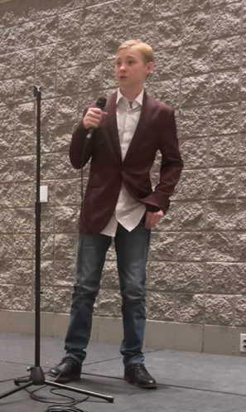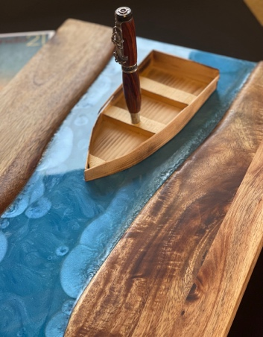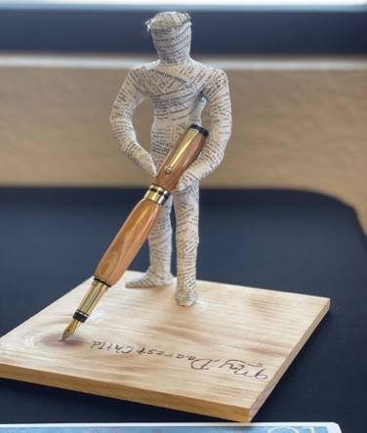

For registration and more info
please call or email
Amy Long at 885-4389 or youth@carlsbadfirst.com
This benefit shoot funds youth fine arts

2/1/22
Amy Long
Carlsbad First Assembly
1502 West Mermod St.
Carlsbad, NM 88220

Dear Friends and Business Owners,
We are requesting your partnership through a tax-deductible sponsorship to help support our youth group, Now Generation. Now Generation is a youth program that supports teenagers in discovering, developing, and deploying the God-given gifts within them, as well as provide a spiritual resource and healthy outlet for them to participate and engage in. Now Generation is a 501(c)3 because Carlsbad First Assembly is the non-profit organization that supports the programs and services provided by Now Generation. We compete in a state and national level competition through the Assemblies of God, called Fine Arts.
Fine Arts Festival is a discipleship tool of the AG Youth Ministries designed to help students discover, develop, and deploy their ministry gifts and to learn about their God-given abilities and talents.
We, along with leaders and family members, encourage students to develop their gifts and then use them in their schools, churches, and communities. Fine Arts Festivals enable students to experience a time of learning through evaluations, workshops, and interaction with other students.
Beginning in September each year, over 65,000 junior and senior high school students begin preparing their entries for the district and National Fine Arts Festivals. Students may enter as many as 80+ categories offered in 7 main divisions: Art, Communication, Dance, Drama, Instrumental, Vocal, and Writing.
Now Generation includes high school and middle school students. We have the opportunity to participate at the state level in Albuquerque with an average per member cost in excess of $250. Then, if students advance, the national level and the location of nationals changes every year. In the year of 2021, National Fine Arts took place in Orlando, Florida and we had two students compete at the national level in 3D Art and Short Sermon, which both enhanced their creative and communication skills. Once students advance to the national level, the cost increases exponentially. The average per member cost for a student to travel to nationals is roughly $1000 (which includes, hotel/transportation/food for a week and airplane tickets).
Your sponsorship will help with uniformed t-shirts, travel expenses, registration fees, and project supplies. Now Generation’s goal is to reduce or eliminate the costs incurred by our youth members. As their youth pastor, I am passionate about our youth, but we need your help as Fine Arts is a high-cost festival, but Fine Arts has the potential to be much more than “just a festival.” We desire to stand together with students as they open the doors to their futures and your sponsorship would be instrumental in making this possible.

If making a donation, please complete the form on the back of this letter. On behalf of Now Generation and Carlsbad First Assembly we thank you for your time and consideration.
Sincerely,
Now Generation and Youth Pastor and Leaders

For further inquiries contact:
Amy Long
Youth Pastor, Carlsbad First Assembly
Phone: (575) 885-4389
Email: youth@carlsbadfirst.com
Facebook: https://www.facebook.com/carlsbadnowyouth
Follow us on Facebook to stay up to date on how the youth do at the events and see where your donations are going.
Date: _________________________________________________________________
Sponsor: ______________________________________________________________
Address: ______________________________________________________________
Phone: _______________________________________________________________
Email: ________________________________________________________________
Contact: ______________________________________________________________
Gold Sponsorship ($3,500) Silver Sponsorship ($1,000)

Signature: _____________________________________________________________
Donation Amount: ___________________ Check Number: ______________________

Please make checks payable to: Carlsbad First Assembly
Mail to: Carlsbad First Assembly
1502 West Mermod
Carlsbad, NM 88220
ATTN: Amy Long

Thank you for your support of youth fine arts. Your contribution is greatly appreciated.

Now Generation
Benefit Shoot

ATC Shooting Sports, 1530 Morris Road, Carlsbad, NM

ALL AMMUNITION FOR THIS SHOOT MUST BE PURCHASED AT ATC SHOOTING RANGE
SATURDAY, APRIL 2ND, 2022
8:AM STARTING TIME
Individual/Team Registration Form

Individual Entry - $150.00 (individual shooter fee and includes targets)

Name: _________________________ Email: _________________________________

Address: ________________________________________________________________

City/State/Zip: _____________________________ Cell Phone: ____________________

Team Entry (team entry fee and includes targets)
Grand Champion Entry Reserve Champion Entry Golden Gate Entry

$1,250
$600
$5,000

Shooter #1 Name: __________________________________ Email: ___________________________________

Shooter #2 Name: __________________________________ Email: ___________________________________

Shooter #3 Name: __________________________________ Email: ___________________________________

Shooter #4 Name: __________________________________ Email: ___________________________________

